Series
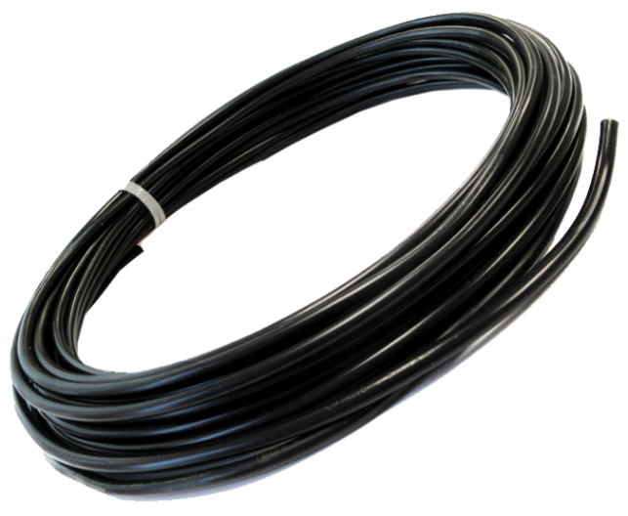
TXLP1
Single Conductor Series Resistance Custom Cable Assembly for Snow Melting and De-Icing Applications

Features
Voltage - 120V to 600V (max).
Cold lead - Standard length 15 ft. (4.57 m).
Longer lengths available (See Options table).
Cable diameter - 6 mm to 6.5 mm (See Models table for details).
Bending radius, minimum - 5x cable diameter.
Maximum operating
temperature - 65 ⁰C (149 ⁰F).
Construction - Stranded resistance heating wire with XLPE insulation, tinned copper
grounding conductor, aluminum sheath, and PVC outer jacket.
Warranty - 10-year limited warranty on the resistance cable.
Controls - The slab temperature must be monitored and controlled.
Requires a ground fault circuit-interrupter (GFCI).

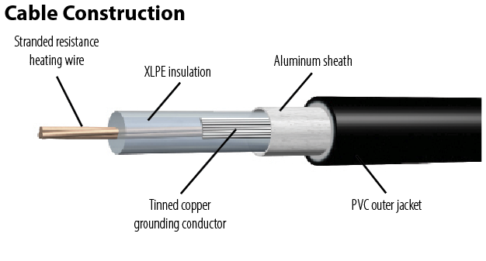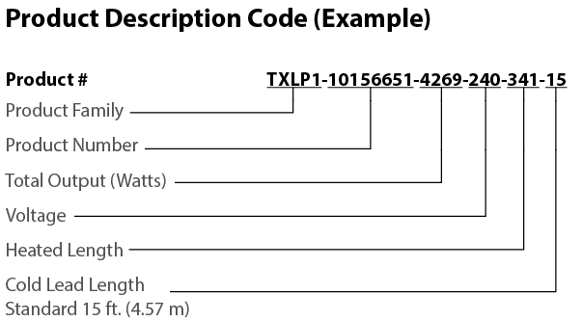
Models
Product # | Resistance  (Ohms)  Per metre | Cable Outer Diameter | Weight Per |  | Qty
 |  | mm | 100 m  kg | 300 ft.  lb
TXLP1-10156651 | 12.7 | 6.0 | 4.6 | 11.1
TXLP1-10156650 | 7.7 | 6.0 | 4.6 | 11.1
TXLP1-10156649 | 5.35 | 6.0 | 4.6 | 11.1
TXLP1-10156648 | 3.5 | 6.1 | 4.9 | 11.8
TXLP1-10156647 | 2.5 | 6.1 | 5.1 | 12.3
TXLP1-10156646 | 1.4 | 6.1 | 5.0 | 12.0
TXLP1-10156645 | 1.0 | 6.3 | 5.2 | 11.8
TXLP1-10156644 | 0.7 | 6.3 | 5.1 | 12.3
TXLP1-10156613 | 0.49 | 6.3 | 5.3 | 12.0
TXLP1-10156612 | 0.3 | 6.3 | 5.3 | 12.8
TXLP1-10156611 | 0.2 | 6.3 | 5.3 | 12.8
TXLP1-10156610 | 0.13 | 6.5 | 5.6 | 12.5
TXLP1-10156609 | 0.09 | 6.3 | 5.3 | 12.8
TXLP1-10156608 | 0.07 | 6.5 | 5.6 | 13.4
TXLP1-10156607 | 0.05 | 6.5 | 5.7 | 13.6
TXLP1-10156606 | 0.02 | 6.5 | 5.8 | 13.8
TXLP1-10156651 | 12.7 | 6.0 | 4.6 | 11.1
TXLP1-10156650 | 7.7 | 6.0 | 4.6 | 11.1
TXLP1-10156649 | 5.35 | 6.0 | 4.6 | 11.1
TXLP1-10156648 | 3.5 | 6.1 | 4.9 | 11.8
TXLP1-10156647 | 2.5 | 6.1 | 5.1 | 12.3
TXLP1-10156646 | 1.4 | 6.1 | 5.0 | 12.0

Options
Product # | Description | Qty
Factory installed only
25 | 25 ft. (2.3 m) cold lead
50 | 50 ft. (15 m) cold lead
75 | 75 ft. (23 m) cold lead
100 | 100 ft. (30.48 m) cold lead
Kit
BRIPPS-75 | 75 ft. (23 m) galvanized steel cable clip strip for installation
KIT-SP3 | Repair kit
HT-2-SIGN | Lamacoid snow melt warning sign

Specifications may change without prior notice
Project: | Approval  Information
Consultant Engineer:
Electricial Contractor:
Distributor:
Date:
Contact at manufacturer:
Comments:

